**EX.NO:7 DATE:4/9/2024**

**Reg.no:220701048**

**PROLOG- FAMILY TREE**

**AIM :** To develop a family tree program using PROLOG with all possible facts, rules, and queries.

**CODE**:  
/*FACTS :: */

male(peter).

male(john).

male(chris).

male(kevin).

female(betty).

female(jeny).

female(lisa).

female(helen).

parentOf(chris,peter).

parentOf(chris,betty).

parentOf(helen,peter).

parentOf(helen,betty).

parentOf(kevin,chris).

parentOf(kevin,lisa).

parentOf(jeny,john).

parentOf(jeny,helen).

/*RULES :: */

/* son,parent

* son,grandparent*/

father(X,Y):- male(Y), parentOf(X,Y).

mother(X,Y):- female(Y), parentOf(X,Y).

grandfather(X,Y):- male(Y),parentOf(X,Z),parentOf(Z,Y).

grandmother(X,Y):- female(Y),parentOf(X,Z),parentOf(Z,Y).

brother(X,Y):- male(Y), father(X,Z), father(Y,W),Z==W.

sister(X,Y):- female(Y), father(X,Z),father(Y,W),Z==W.

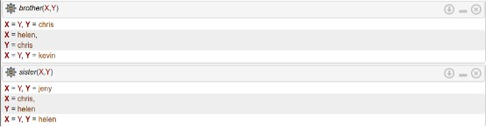

**OUTPUT:**

